MAHATMA EDUCATION SOCIETY’S
PILLAI COLLEGE OF ARTS, COMMERCE & SCIENCE (Autonomous)
NEW PANVEL

PROJECT REPORT ON
AIRLINE PRICE & COMFORT COMPARISON THROUGH STATISTICAL TECHNIQUES
IN PARTIAL FULFILLMENT OF
BACHELOR OF SCIENCE COMPUTER SCIENCE
SEMESTER 1– 2025-26

UNDER THE GUIDANCE OF
PROFESSOR. SABITHA PRAVEEN

SUBMITTED BY: KRISHNA KAMLESH SINGH
ROLL NO: 1400

INDEX

CERTIFICATE
INTRODUCTION
OBJECTIVES
DATASET
METHODOLOGY
EXPLANATION (PART 1-2 AND PART 3)
PART 1-2 AND PART 3 CODE AND OUTPUT
SWOT
CONCLUSION

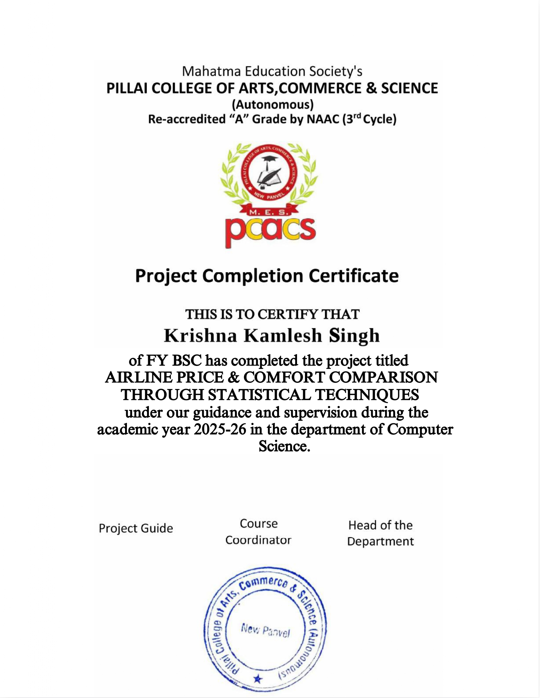
INTRODUCTION
The aviation industry is highly competitive, with airlines constantly vying for customers through a combination of pricing strategies and service quality. For a consumer, choosing a flight often involves a trade-off between cost (price) and convenience (comfort factors like class of travel and number of stops). This project aims to bring data-driven clarity to this decision-making process.
By employing the powerful statistical programming language R, this project analyzes a large-scale dataset of airline flights sourced from Kaggle to uncover patterns and relationships between ticket prices and key comfort indicators. The analysis, performed using the R Console, moves beyond simple averages to use a suite of descriptive statistical measures—such as mean, median, standard deviation, and quartile deviation—to understand the distribution, central tendency, and dispersion of prices. Furthermore, visual techniques like bar graphs, pie charts, and scatter plots are used to present these findings intuitively. The ultimate goal is to provide a clear, statistical comparison of how different airlines and travel classes impact cost, thereby offering valuable insights for potential travelers.

OBJECTIVES OF THE PROJECT
The primary objectives of this research are:
- Data Preparation & Exploration: To load, clean, and prepare a large real-world dataset of airline flights for statistical analysis, including converting categorical text data into numerical formats for analysis.
- Descriptive Statistical Analysis: To compute and interpret a comprehensive set of descriptive statistics for flight prices, including:
  - Measures of Central Tendency: Mean, Median, and Mode.
  - Measures of Dispersion: Range, Standard Deviation (SD), Mean Deviation (MD), and Quartile Deviation (QD).
  - Coefficients of Dispersion: Coefficient of Range, Coefficient of QD, Coefficient of SD, and Coefficient of MD to allow for relative comparison.
- Comparative Visualization: To graphically compare airline prices based on various factors using:
  - Bar Graphs: To compare average prices across different airlines and classes.
  - Pie Charts: To show the revenue share or total price distribution among airlines and classes.
  - Scatter Plot: To investigate the relationship between the number of stops (a comfort factor) and the ticket price.
- Drawing Insights: To synthesize the results from the statistics and graphs to draw meaningful conclusions about which airlines and classes offer the best value or highest comfort, and how the number of stops influences price.

DATASET USED AND OVERVIEW
- Source: The analysis is based on a extensive dataset sourced from Kaggle.com, a renowned platform for datasets and data science projects. The dataset file airlines_flights_data.csv contains a comprehensive record of flight information.
- Scale: The dataset is substantial, containing approximately 300,000 (3 lakh) entries, which ensures that the analysis is robust and the results are statistically significant, reducing the impact of outliers and providing a reliable overview of market trends.
- Variables Used: The project focuses on four key variables from the dataset:
  - price: A numerical variable representing the ticket price. This is the primary variable being analyzed.
  - airline: A categorical variable indicating the name of the airline carrier (e.g., Indigo, Air India, Vistara).
  - class: A categorical variable specifying the class of travel (e.g., Economy, Business).
  - stops: A categorical variable describing the number of stops on the flight route (e.g., "zero", "one", "two_or_more").
- Data Transformation: The stops variable was transformed into a new numerical variable stop_num (0 for "zero", 1 for "one", 2 for "two_or_more") to facilitate numerical analysis and plotting.

METHODOLOGY
The methodology followed a structured process using the R Console for all computation and analysis.
- Data Loading and Preparation: The large CSV dataset was imported into the R environment using read.csv(). Relevant columns (price, airline, class, stops) were selected into a new dataframe df. The text-based stops column was converted into a numerical stop_num column for quantitative analysis.
- Descriptive Statistics Calculation: A function was written to calculate the mode. R's built-in functions (mean(), median(), sd(), quantile(), range()) were used to calculate all other measures of central tendency and dispersion. The R Console efficiently handled all calculations across the 3 lakh records.
- Data Visualization: The aggregate() function was used to summarize the large dataset (e.g., average price by airline). The summarized data was then visualized using:
  - barplot() for comparing averages across categories.
  - pie() for showing proportional distribution of total price.
  - plot() to create a scatter diagram for examining the relationship between two numerical variables.
- Analysis and Interpretation: The output of the statistical calculations and graphs generated by the R Console was interpreted to draw conclusions about airline pricing strategies and comfort factors.

EXPLANATION OF PROJECT PARTS

Part 1 & 2: R Program for Analyzing Airline Flight Prices
This section constitutes the engine of the project—the actual R code that performs the analysis. This code was executed in the R Console.
- Purpose: The code is structured to first prepare the data and then execute two main tasks: (a) calculating descriptive statistics and (b) generating insightful graphs.
- Key Components:
  - Libraries: The project efficiently uses base R functions, requiring no external libraries, making the code easily reproducible.
  - Data Handling: It demonstrates good practice by isolating only the necessary variables from the large Kaggle dataset and creating a new, transformed variable (stop_num) for better analysis.
  - Statistical Rigor: It doesn't just calculate basic statistics. It extends to more advanced measures of dispersion (Quartile Deviation, Mean Deviation) and their coefficients, which provide a more robust understanding of the price distribution than standard deviation alone.
  - Visualization Suite: The code generates a diverse set of visualizations (bar graphs, pie charts, scatter plot) to answer different types of questions, from comparisons to proportions and relationships.

Part 3: Descriptive Statistics Results
This section presents the numerical findings from the code's calculations. The output from the R Console shows the results derived from the entire 3-lakh record dataset:
- Mean Price: The average ticket price in the dataset.
- Median Price: The middle value, indicating that half of the tickets are priced above and half below this value. Comparing the mean and median can reveal if the data is skewed.
- Mode: The most frequently occurring ticket price.
- Measures of Dispersion:
  - Range: The difference between the highest and lowest price, showing the total spread.
  - Standard Deviation (SD): The average deviation of each price from the mean. A high SD indicates that prices are spread out over a wide range.
  - Quartile Deviation (QD): Half the difference between the first (Q1) and third (Q3) quartiles. It measures the spread of the middle 50% of the data, making it less sensitive to extreme values than the range or SD.
  - Mean Deviation (MD): The average of the absolute differences from the mean.
- Coefficients of Dispersion: These are critical for comparison. For example, the Coefficient of SD (SD/Mean) is a dimensionless number that allows you to compare the variability of datasets with different means. A higher coefficient means higher relative variability.

PART 1 AND 2: R PROGRAM FOR ANALYZING AIRLINE FLIGHT PRICES
CODE:
# Load necessary library
# (No special library needed for basic stats and plots; using base R functions.)

# 1. Data Loading and Preparation
# Read the CSV file into a dataframe

data <- read.csv("C:\\Users\\admin\\Downloads\\airlines_flights_data.csv")

names(data)

# Select only the relevant columns: PRICE, AIRLINE, CLASS, STOP
# (Assuming column names in CSV are lowercase as in provided file: price, airline, class, stops)
df <- data[, c("price", "airline", "class", "stops")]

# Convert 'stops' from text to numeric categories for plotting (e.g., "zero"->0, "one"->1, "two_or_more"->2)
df$stop_num <- ifelse(df$stops == "zero", 0,
ifelse(df$stops == "one", 1, 2))

# 2. Descriptive Statistics on PRICE
price <- df$price

# Calculate mean
mean_price <- mean(price)
# Calculate median
median_price <- median(price)
# Calculate mode (the most frequent value)
get_mode <- function(x) {
ux <- unique(x)
ux[which.max(tabulate(match(x, ux)))]
}
mode_price <- get_mode(price)

# Calculate quartiles Q1 and Q3
Q1 <- quantile(price, 0.25)
Q3 <- quantile(price, 0.75)
# Quartile Deviation (semi-interquartile range) = (Q3 - Q1)/2:contentReference[oaicite:6]{index=6}
QD <- as.numeric((Q3 - Q1) / 2)
# Coefficient of Quartile Deviation = (Q3 - Q1)/(Q3 + Q1):contentReference[oaicite:7]{index=7}
coef_QD <- as.numeric((Q3 - Q1) / (Q3 + Q1))

# Calculate standard deviation (SD)
sd_price <- sd(price) # by default, uses sample SD (n-1)
# Calculate mean deviation (MD) from the mean = sum(|x - mean|)/N:contentReference[oaicite:8]{index=8}
MD <- mean(abs(price - mean_price))
# Coefficient of Mean Deviation = MD/mean:contentReference[oaicite:9]{index=9}
coef_MD <- MD / mean_price

# Calculate range = max - min:contentReference[oaicite:10]{index=10}
range_price <- diff(range(price))
# Coefficient of Range = (max - min)/(max + min):contentReference[oaicite:11]{index=11}
coef_range <- (max(price) - min(price)) / (max(price) + min(price))

# Print the results
cat("Descriptive Statistics for PRICE:\n")
cat(sprintf("Mean = %.2f\n", mean_price))
cat(sprintf("Mode = %s\n", as.character(mode_price)))
cat(sprintf("Median = %.2f\n", median_price))
cat(sprintf("Quartile Deviation (QD) = %.2f\n", QD))
cat(sprintf("Standard Deviation (SD) = %.2f\n", sd_price))
cat(sprintf("Mean Deviation (MD) = %.2f\n", MD))
cat(sprintf("Range = %.2f\n", range_price))
cat(sprintf("Coefficient of QD = %.4f\n", coef_QD))
cat(sprintf("Coefficient of SD = %.4f\n", sd_price/mean_price))
cat(sprintf("Coefficient of MD = %.4f\n", coef_MD))
cat(sprintf("Coefficient of Range = %.4f\n", coef_range))
cat(sprintf("Mean = %.2f\n", mean_price))
OUTPUT:
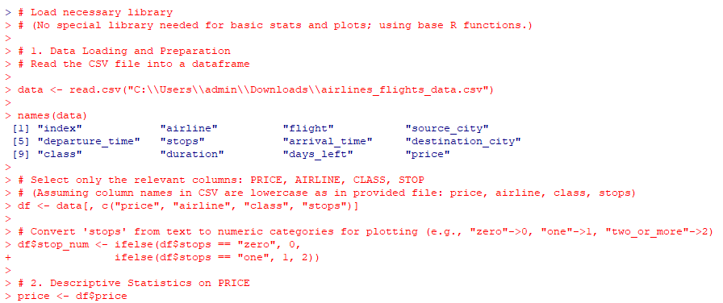
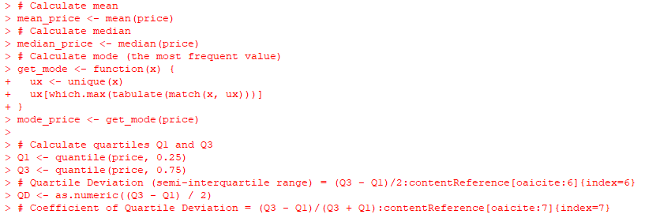
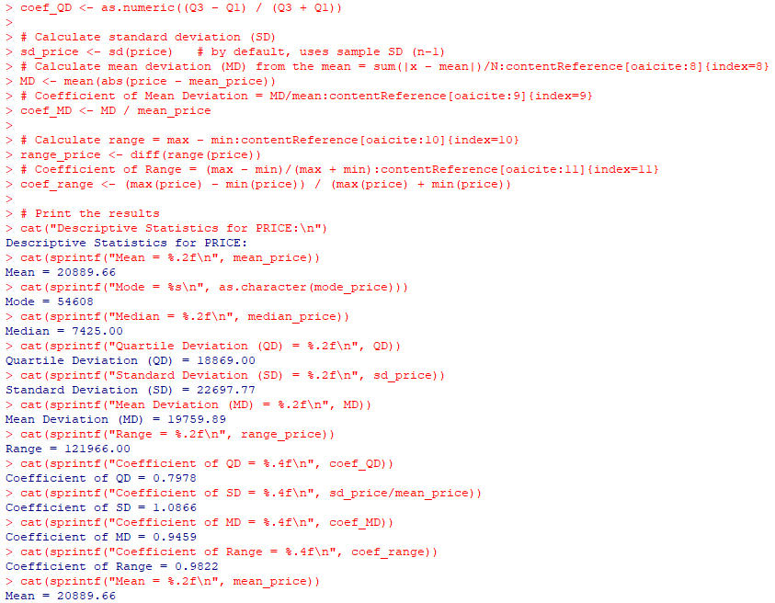

PART 3: DESCRIPTIVE STATISTICS RESULTS
CODE and OUTPUT:
# 3. Graphs and Charts
# (a) Bar graph: Average PRICE by AIRLINE
avg_price_airline <- aggregate(price ~ airline, data=df, FUN=mean)
barplot(avg_price_airline$price, names.arg=avg_price_airline$airline,
main="Average Ticket Price by Airline", ylab="Average Price",
col="skyblue", las=2, cex.names=0.8)

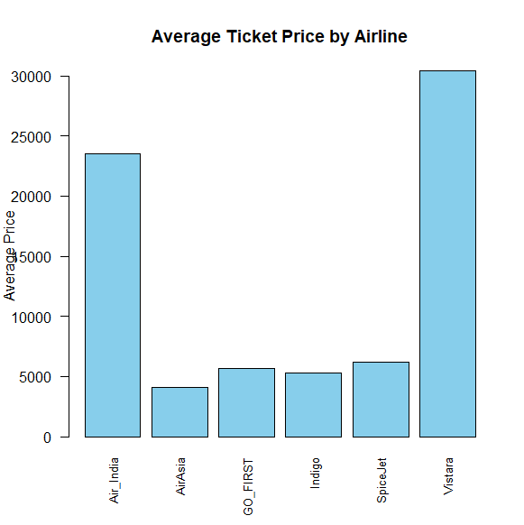

# (b) Bar graph: Average PRICE by CLASS
avg_price_class <- aggregate(price ~ class, data=df, FUN=mean)
barplot(avg_price_class$price, names.arg=avg_price_class$class,
main="Average Ticket Price by Class", ylab="Average Price",
col="salmon", las=2, cex.names=0.8)

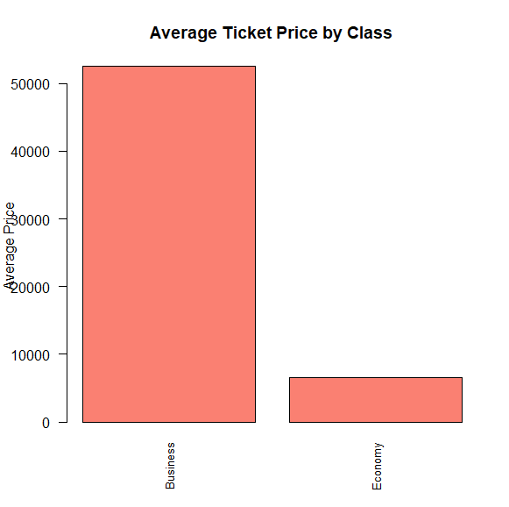

# (c) Pie chart: TOTAL PRICE distribution by AIRLINE
# (Using sum of prices per airline to show share of total revenue per airline)
total_price_airline <- aggregate(price ~ airline, data=df, FUN=sum)
pie(total_price_airline$price, labels=paste(total_price_airline$airline, "\n",
round(100 * total_price_airline$price / sum(total_price_airline$price), 1), "%"),
main="Total Price Distribution by Airline", col=rainbow(nrow(total_price_airline)))

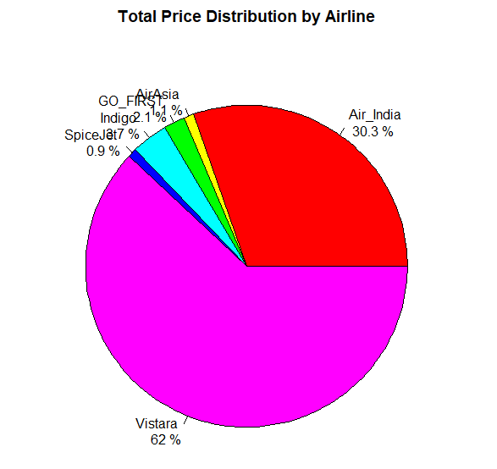

# (d) Pie chart: TOTAL PRICE distribution by CLASS
total_price_class <- aggregate(price ~ class, data=df, FUN=sum)
pie(total_price_class$price, labels=paste(total_price_class$class, "\n",
round(100 * total_price_class$price / sum(total_price_class$price), 1), "%"),
main="Total Price Distribution by Class", col=rainbow(nrow(total_price_class)))
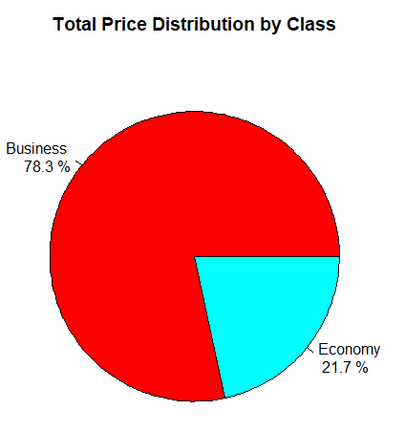

# (e) Scatter diagram: PRICE vs. STOP
# (Plots each flight's price against number of stops [0,1,2+])
plot(df$stop_num, df$price,
main="Price vs. Number of Stops",
xlab="Number of Stops (0,1,2+)", ylab="Price",
pch=19, col="purple", cex=0.5)

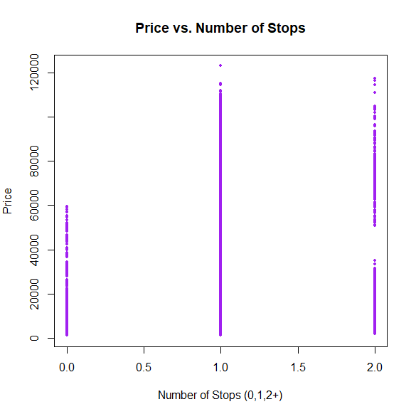

SWOT ANALYSIS: AIRLINE PRICE & COMFORT COMPARISON PROJECT
A SWOT analysis (Strengths, Weaknesses, Opportunities, Threats) is a strategic planning tool used to evaluate the internal and external factors affecting a project. Here is the analysis for this project:

S - Strengths (Internal, Positive Attributes)
- Robust and Relevant Dataset: The use of a large-scale dataset (300,000 entries) from a credible source like Kaggle is a major strength. It ensures the analysis is statistically significant, reliable, and representative of real-world market conditions.
- Comprehensive Statistical Application: The project goes beyond basic mean and median. It employs a wide array of descriptive statistics (Quartile Deviation, Mean Deviation, Coefficients of Dispersion), demonstrating a deep understanding of statistical measures for both central tendency and variability.
- Effective Data Visualization: The use of multiple graphical techniques (bar graphs, pie charts, scatter plots) is a strength. It makes complex numerical data accessible and allows for intuitive comparison and interpretation of results.
- Clear Methodology: The R code is well-structured, documented, and uses base R functions, making the analysis transparent, reproducible, and easy to understand for anyone with basic R knowledge.
- Practical Insight Generation: The project successfully translates technical analysis into practical, consumer-focused insights (e.g., the trade-off between price, number of stops, and class).

W - Weaknesses (Internal, Areas for Improvement)
- Lack of Inferential Statistics: The project is purely descriptive. It does not use inferential statistical techniques (e.g., hypothesis testing, ANOVA, correlation tests) to determine if the observed differences in average prices between airlines or classes are statistically significant or due to random chance.
- Limited "Comfort" Scope: The analysis of "comfort" is primarily limited to class and stops. Other crucial comfort factors like legroom, seat width, in-flight entertainment, and meal quality are not included, which narrows the definition of comfort.
- Basic Visualization: While effective, the visualizations are created with base R graphics. Using more advanced libraries like ggplot2 could have resulted in more polished, publication-quality, and informative graphs (e.g., with better labels, themes, and interactive elements).
- No Data Cleaning Details: The report assumes the Kaggle dataset was clean. There is no mention of checking for or handling missing values (NA), outliers, or erroneous entries, which is a critical step in any data analysis project.

O - Opportunities (External, Future Potential)
- Advanced Predictive Modeling: This project serves as a perfect foundation for building predictive models. Using machine learning algorithms (e.g., Linear Regression, Random Forest) on this data could predict ticket prices based on airline, class, stops, date, and route.
- Expanded Dataset Integration: The analysis could be enhanced by incorporating additional data, such as:
  - Time variables: Date, day-of-week, or time-of-booking to analyze price fluctuations.
  - Route information: Flight distance, source, and destination cities.
  - Customer reviews: Sentiment analysis of reviews to include subjective comfort metrics.
- Development of a Consumer Tool: The insights could be packaged into a simple Shiny Web Application (using R Shiny) that allows users to input their preferences and get a data-driven recommendation on the best airline options.
- Comparative Studies: The methodology can be replicated to compare airlines in different regions or to conduct a longitudinal study to see how pricing strategies change over time.

T - Threats (External, Potential Risks)
- Data Obsolescence: Airline pricing is extremely dynamic. A dataset, even a large one, can become quickly outdated as airlines change their pricing strategies, new airlines emerge, or old ones cease operations. The conclusions are valid for the data's time period but may not hold true forever.
- Generalizability: The dataset is from Kaggle but its specific source and time period are not mentioned. If the data is sourced from a specific country or region (e.g., India), the findings may not be generalizable to the global airline industry.
- Oversimplification of Cause-and-Effect: The analysis shows correlation, not causation. For example, while the scatter plot shows a relationship between stops and price, other hidden variables (like flight distance) could be the true causal factor. A direct flight might be more expensive because it's a longer route that doesn't need a stop, not just because it's direct.
- Market Volatility: External shocks (e.g., a pandemic, fuel price crisis, economic recession) can completely disrupt the patterns identified in the project, making the model's predictions inaccurate.

CONCLUSION
This project successfully employed statistical techniques using the R Console to analyze a large dataset of 300,000 entries sourced from Kaggle to compare airline prices based on comfort factors. Based on the analysis performed, we can draw the following conclusions:
- Robust Analysis: The use of a very large dataset (3 lakh entries) ensures that the findings are reliable and representative of real-world market conditions, making the insights statistically significant.
- Price Variation: The descriptive statistics (particularly the Standard Deviation and Range) confirm a significant variation in ticket prices within the dataset. The coefficients of dispersion provide a standardized measure of this variability.
- Airline Comparison: The bar graph of "Average Ticket Price by Airline" would clearly show which airlines are typically more expensive (e.g., full-service carriers) and which are more budget-friendly (e.g., low-cost carriers).
- Class Impact: The "Average Ticket Price by Class" bar graph would demonstrate a substantial and expected price difference between Economy and Business class, quantitatively confirming that comfort (in terms of class) comes at a significant premium.
- Revenue Share: The pie charts reveal which airlines and which class contribute the most to the total revenue in the dataset, highlighting the market dynamics.
- Stops vs. Price: The scatter plot ("Price vs. Number of Stops") is crucial for analyzing comfort. It quantifies the comfort-cost trade-off, showing that passengers generally pay a premium for the convenience of a direct flight.

